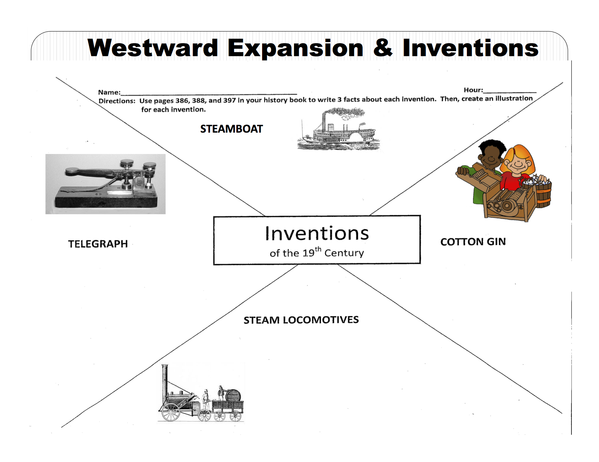
Name ________________________________________________________ Teacher: Chalmers

Inventions in Westward Expansion
Cotton Gin—
•Machine separated _______________________________ from cotton fiber
•Invented by ______________________________ in 1793
•Led to an increase in cotton-growing ___________________________________ and ________________________
Steamboat—
•Lots of early attempts
•1st made successful in U.S. by ______________________________________ in _______
•Allowed for ______________________________________________ throughout the U.S.
Steam Locomotive—
•1st railroad track opened in U.S. in __________________
•Railroad tracks spread quickly, especially in ___________________________
•____________________________________________ railroad finished in ____________
Telegraph—
•Used a code to send messages over a _____________________
•__________________________________ given credit for its invention
•1st telegraph line built in U.S. in __________________

