Name _____________________________________________________________________ Period ___________
Progressives Note Taking

Use this graphic organizer to take notes on each of the progressives.
Progresive | Notes
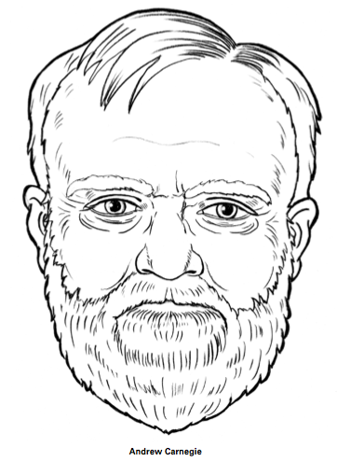 | Known as the King of S____________, Carnegie was very generous. Later in his life he ________________________________________________________________.
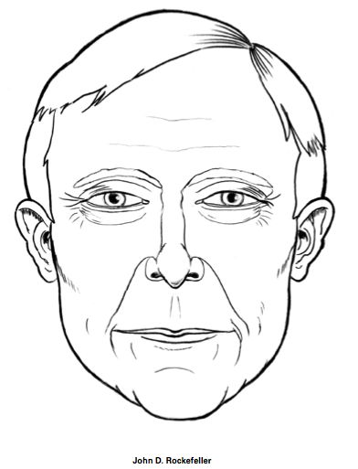 | Founder of the _______________________________, Rockefeller controlled 90% of all oil production in the United States and became this country’s first ______________________. Later in his life he gave substantial amounts of money to _________________________________________.
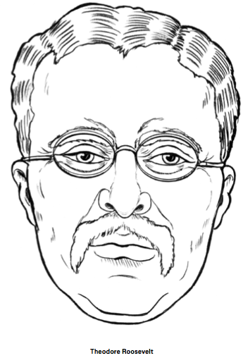 | As President of the U.S., Roosevelt broke up ____________________________. Roosevelt did not want to destroy corporations, he just wanted to make sure that they serve the public. One of the companies he “____________________” was __________________________________.
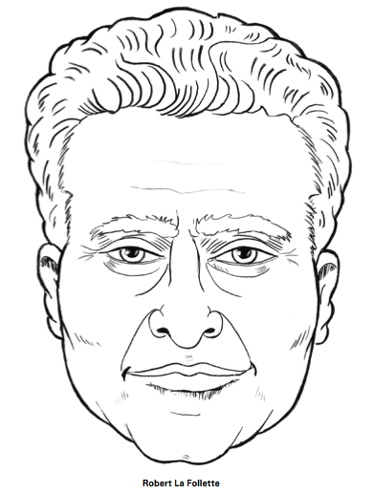 | La Follette fought corruption in _______________________. He was elected governor of Wisconsin where he instituted the _________________________. He believed that all people should have a larger say in elections.
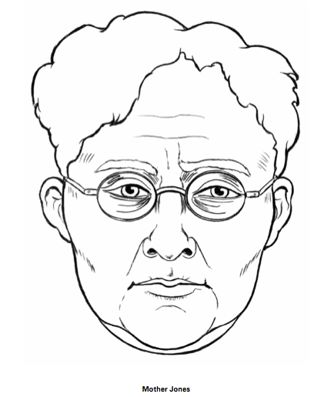 | Mother Jones worked tirelessly to fight practices of ____________________ _______________. She also helped improve working conditions for adults.
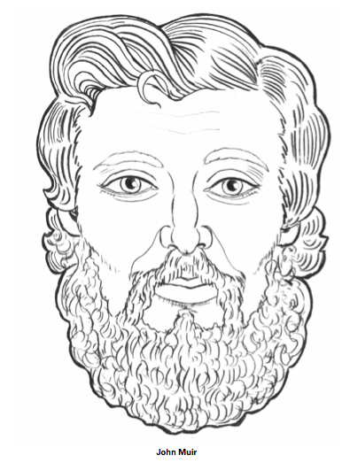 | John Muir was a conservationist. He believed that government should protect nature and wildlife ( the _________________________________). His writings and speeches helped to convince Congress to create Yosemite National Park.
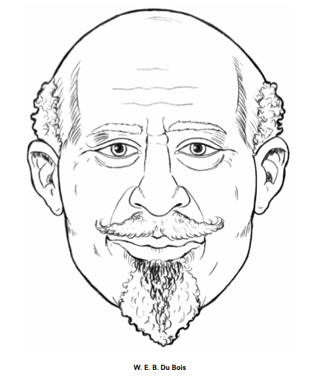 | Du Bois fought against the Jim Crow laws of the South. He fought for ______________________________________________________________. He helped to found the NAACP.
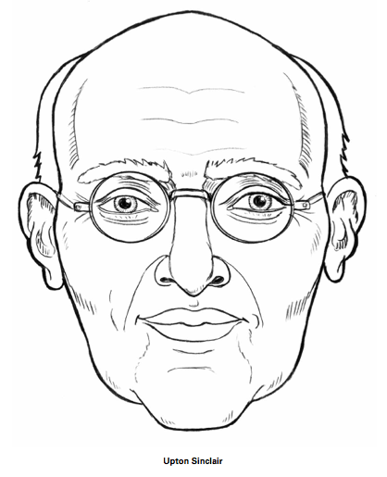 | The author of the book The _____________________________, Sinclair told of the disgusting working conditions in Chicago’s meatpacking industry. The Jungle also told of how beef & sausages were processed. This included meet being processed with ________________, poisoned bread, and __________________. His writing led to the __________________________ _____________________________.
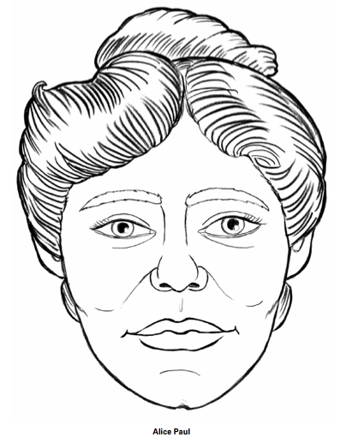 | Fought for women’s rights. Her protests led to the passing of the _______________________________________________ . No longer could anyone be denied the right to _______________________ based on gender.

