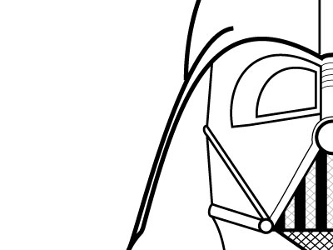
The Dark Side of the Twenties (1920’s)
Notes
A Time of economic growth, more ___________________________, fun, and freedom!
But there was a “Dark Side” to the Twenties
________________________ – Refusal to accept people who are different because of:
  - R__________________________
  - Background
  - Opinions
  - B__________________________

™People who were left out included:
  - F___________________
  - I___________________
  - African Americans

The “_________________________________” – The Federal Government arrested communists and other R___________________________ who wanted to overthrow the government.

  - Often without any evidence
  - Trampled C__________________ Liberties (guaranteed freedoms)
  - Fear of Radicalism outweighed civil rights.

Over to the other side

Revival of the Ku Klux Klan (KKK):
  - Mob violence against:
    - __________________________________________
    - Immigrants
    - C_________________________________________
    - J__________________________________________
All seen as “_________________________________”

Discrimination &Limits on Immigration:
  - The numbers of people who could come to America was __________________ to 97,000 in 1929.
  - None from A__________________
  - Couldn’t marry ___________________________ people, or own ___________________.

The S________________________ Trial:
  - Tennessee – A teacher taught the _______________________________________ violating state law.
  - A trial was held. Great lawyers battled.
  - Traditionalists wanted the “____________________________________________________” as taught in the B_________________________
  - Scopes was found _______________________. (Fined $100.00)
  - The debate still goes on today.

