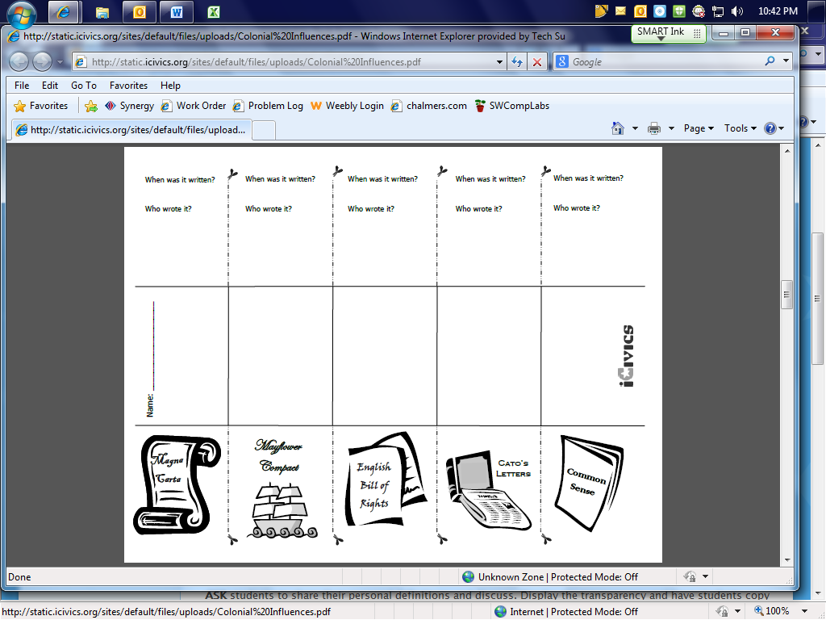**5 Big Ideas of the Constitution of the United States**

|  |  |  |  |  |
| --- | --- | --- | --- | --- |
|  |  |  |  |  |
| This is a:   * Government Document * Agreement between individuals * Collection of Newspaper articles * Pamphlet | This is a:   * Government Document * Agreement between individuals * Collection of Newspaper articles * Pamphlet | This is a:   * Government Document * Agreement between individuals * Collection of Newspaper articles * Pamphlet | This is a:   * Government Document * Agreement between individuals * Collection of Newspaper articles * Pamphlet | This is a:   * Government Document * Agreement between individuals * Collection of Newspaper articles * Pamphlet |
| When was it written?  Who wrote it? | When was it written?  Who wrote it? | When was it written?  Who wrote it? | When was it written?  Who wrote it? | When was it written?  Who wrote it? |
| What was the purpose of this document? | What was the purpose of this document? | What was the purpose of this document? | What was the purpose of this document? | What was the purpose of this document? |
| **C:\Users\nchalmer\AppData\Local\Microsoft\Windows\Temporary Internet Files\Content.IE5\AH7921O8\MC900233518[1].wmfBIG IDEAS:** | **C:\Users\nchalmer\AppData\Local\Microsoft\Windows\Temporary Internet Files\Content.IE5\AH7921O8\MC900233518[1].wmfBIG IDEAS:** | **C:\Users\nchalmer\AppData\Local\Microsoft\Windows\Temporary Internet Files\Content.IE5\AH7921O8\MC900233518[1].wmfBIG IDEAS:** | **C:\Users\nchalmer\AppData\Local\Microsoft\Windows\Temporary Internet Files\Content.IE5\AH7921O8\MC900233518[1].wmfBIG IDEAS:** | **C:\Users\nchalmer\AppData\Local\Microsoft\Windows\Temporary Internet Files\Content.IE5\AH7921O8\MC900233518[1].wmfBIG IDEAS:** |